附件1

宁东基地第四届群众性篮球比赛活动报名表

组 别：（男/女子组） 负责人：

参赛单位： 联系方式：

|  |  |  |  |  |  |  |
| --- | --- | --- | --- | --- | --- | --- |
| 序号 | 队内 职务 | 姓名 | 身份证号 | 联系方式 | 号码 | 备注 |
| 1 | 领队 |  |  |  |  |  |
| 2 | 教练 |  |  |  |  |  |
| 3 |  |  |  |  |  |  |
| 4 |  |  |  |  |  |  |
| 5 |  |  |  |  |  |  |
| 6 |  |  |  |  |  |  |
| 7 |  |  |  |  |  |  |
| 8 |  |  |  |  |  |  |
| 9 |  |  |  |  |  |  |
| 10 |  |  |  |  |  |  |
| 11 |  |  |  |  |  |  |
| 12 |  |  |  |  |  |  |
| 13 |  |  |  |  |  |  |
| 14 |  |  |  |  |  |  |
|  |  |  |  |  |  |  |
|  |  |  |  |  |  |  |

宁东基地第四届群众性足球比赛活动报名表

组 别： 负责人：

参赛单位： 联系方式：

|  |  |  |  |  |  |  |
| --- | --- | --- | --- | --- | --- | --- |
| 序号 | 队内 职务 | 姓名 | 身份证号 | 联系方式 | 号码 | 备注 |
| 1 | 领队 |  |  |  |  |  |
| 2 | 教练 |  |  |  |  |  |
| 3 |  |  |  |  |  |  |
| 4 |  |  |  |  |  |  |
| 5 |  |  |  |  |  |  |
| 6 |  |  |  |  |  |  |
| 7 |  |  |  |  |  |  |
| 8 |  |  |  |  |  |  |
| 9 |  |  |  |  |  |  |
| 10 |  |  |  |  |  |  |
| 11 |  |  |  |  |  |  |
| 12 |  |  |  |  |  |  |
| 13 |  |  |  |  |  |  |
| 14 |  |  |  |  |  |  |
| 15 |  |  |  |  |  |  |
| 16 |  |  |  |  |  |  |
| 17 |  |  |  |  |  |  |

宁东基地第四届运动会羽毛球、乒乓球比赛活动报名表

报名项目：（羽毛球/乒乓球） 负责人：

参赛单位： 联系方式：

|  |  |  |  |  |  |
| --- | --- | --- | --- | --- | --- |
| 序号 | 姓名 | 身份证号 | 联系方式 | 参赛项目 | 备注 |
| 1 |  |  |  | 男单 |  |
| 2 |  |  |  | 女单 |  |
| 3 |  |  |  | 男双 |  |
| 4 |  |  |  |  |
| 5 |  |  |  | 女双 |  |
| 6 |  |  |  |  |
| 7 |  |  |  | 混双 |  |
| 8 |  |  |  |  |
| 9 |  |  |  | 团体 |  |
| 10 |  |  |  |  |
| 11 |  |  |  |  |
| 12 |  |  |  |  |
| 13 |  |  |  |  |
| 14 |  |  |  |  |
| 15 |  |  |  |  |  |
| 16 |  |  |  |  |  |
| 17 |  |  |  |  |  |
| 18 |  |  |  |  |  |
| 19 |  |  |  |  |  |

宁东基地第四届运动会拔河比赛活动报名表

参赛单位： 负责人：

联系方式：

|  |  |  |  |  |
| --- | --- | --- | --- | --- |
| **序号** | **姓名** | **身份证号** | **联系方式** | **备注** |
| 1 |  |  |  |  |
| 2 |  |  |  |  |
| 3 |  |  |  |  |
| 4 |  |  |  |  |
| 5 |  |  |  |  |
| 6 |  |  |  |  |
| 7 |  |  |  |  |
| 8 |  |  |  |  |
| 9 |  |  |  |  |
| 10 |  |  |  |  |
| 11 |  |  |  |  |
| 12 |  |  |  |  |
| 13 |  |  |  |  |
| 14 |  |  |  |  |
| 15 |  |  |  |  |
| 16 |  |  |  |  |
| 17 |  |  |  |  |
| 18 |  |  |  |  |
| 19 |  |  |  |  |
| 20 |  |  |  |  |

宁东基地第四届运动会健身操、工间操比赛活动报名表

|  |  |  |
| --- | --- | --- |
| **参赛单位** | **负责人** | **联系方式** |
|  |  |  |

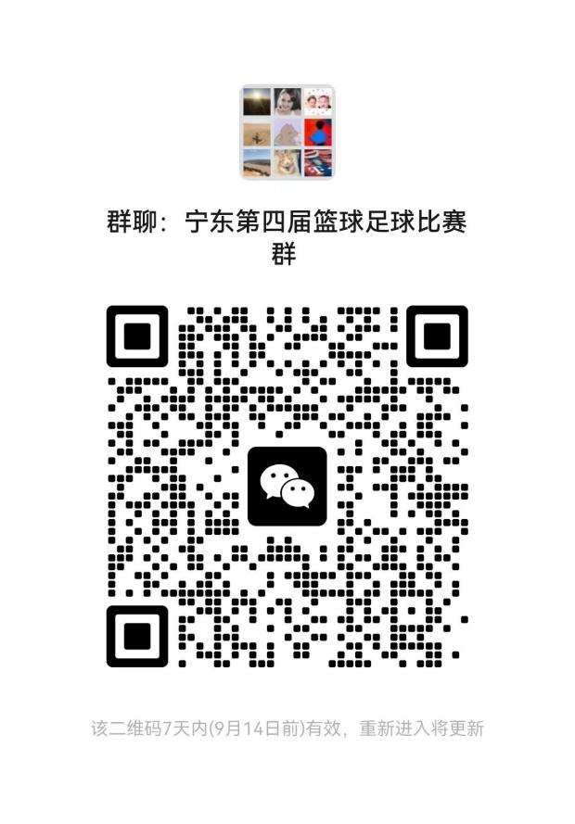 

**篮球足球通知群** **羽毛球乒乓球工间操通知群**